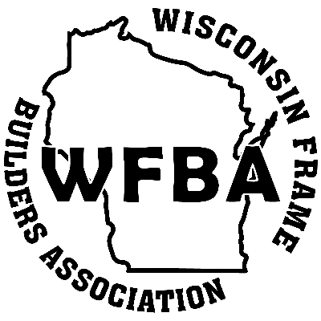
WFBA Annual Conference

February 3 & 4, 2026

Location: The Jefferson Street Inn
201 Jefferson St., Wausau, WI 54403
Tuesday, February 3rd:
6:30 AM – 7:30 AM – Continental Breakfast and Registration
7:30 AM: Bus departs Jefferson St. Inn
8:00 AM – 12:00 PM: Tour #1 - Wausau Supply
Group 1 – Wausau Supply & Diamond Kote
Group 2 – Waudena Millwork
12:00 PM: Bus departs Wausau Supply
Boxed lunches served on the bus
1:00 – 3:00 PM: Tour #2 – Knowlton House Distillery
3:00 PM: Bus departs Knowlton House heading to Jefferson St. Inn
4:00 – 7:00 PM: Dealer Showcase, Speakers & Silent Auction with Bar and Hors d’oeuvres
4:45 PM: Paul Burke, Passionate Keynote Speaker & Executive Advisor, Business Acceleration LLC
Hiring, Developing and Retaining the Ideal Team Player in Your Organization
6:15 PM: Randy Chaffee, Source One Marketing, LLC
Asphalt and Algorithms: A Hybrid Road Warrior’s Playbook for Winning in Sales
7:00 PM: Annual Association Meeting and Awards Ceremony
7:30 PM: Dinner & Prize Giveaway
Wednesday, February 4th:
8:00 AM: Farewell Breakfast Buffet

Event Pricing Information (prices are per person):
WFBA Member Full Event: Tours, Dealer Showcase & Speakers, Annual Meeting, Meals …..$ 175.00
WFBA Hall of Fame Members/Recipients: same as Member Full Event Registration……..$ FREE
Non-member Full Event: Tours, Dealer Showcase & Speakers, Annual Meeting, Meals …..$ 200.00
Dealer Showcase Table: Full Event plus vendor display table …..$ 250.00
Electric Supply for Showcase Table: …..$ 25.00
Additional Dinner Ticket: Admits one person to Tuesday evening events only …..$ 60.00

Hotel Reservation Information (please secure your own hotel reservation):
The Jefferson Street Inn – 201 Jefferson St. Wausau, WI 54403
WFBA Group Rate is $129.00 per night. Call 715-845-6500 and mention the Group Code: WFBA or reference the Wisconsin Frame Builders Association
ROOM BLOCK DEADLINE IS JANUARY 16th
Online option for event registration, sponsorship, and secure payment available at wisconsinframebuilders.org
Or use the printable registration and sponsorship forms to submit via mail, email, or fax

WFBA 2026 Annual Conference Registration Form
Online event registration and secure payment available at www.wisconsinframebuilders.org
Please use the separate Sponsorship Form to sign up for sponsorships. Sponsorship registration is also available in the online version of the registration. For assistance with registration or sponsorship, please contact Emily at 888-294-0084 or at emandich@assnsoffice.com

Primary Contact Information:

Contact Name: ____________________________________________________

Company: ____________________________________________________

Address: ____________________________________________________

City/State/Zip: _______________________________________ Phone: _____________________________
Registrant #1 Name: _________________________________________________

Company Name: ____________________________________________________

Registration Type (check one): Member Full Event $175.00 Dealer Showcase Table $250.00
Non-member Full Event $200.00 Electric Supply for Table $25.00
Tuesday Tours Hall of Fame Member/Recipient

Registrant #2 Name: _________________________________________________

Company Name: ____________________________________________________

Registration Type (check one): Member Full Event $175.00 Additional Dinner Ticket $60.00
Non-member Full Event $200.00 Hall of Fame Member/Recipient

Tuesday Tours

Registrant #3 Name: _________________________________________________

Company Name: ____________________________________________________

Registration Type (check one): Member Full Event $175.00 Additional Dinner Ticket $60.00
Non-member Full Event $200.00 Hall of Fame Member/Recipient

Tuesday Tours

Registrant #4 Name: _________________________________________________

Company Name: ____________________________________________________

Registration Type (check one): Member Full Event $175.00 Additional Dinner Ticket $60.00
Non-member Full Event $200.00 Hall of Fame Member/Recipient
Tuesday Tours

WFBA Member Full Event Registrants: ______ Registrants x $175.00 ea. $
WFBA Hall of Fame Members/Recipients: ______ Registrants x $ 0.00 ea. $
Non-member Full Event Registrants: ______ Registrants x $200.00 ea. $
Dealer Showcase Table: ______ Table x $250.00 ea. $
Electric Supply for Table: ______ $25.00 ea. $
Additional Dinner Ticket: ______ Tickets x $60.00 ea. $
TOTAL AMOUNT: $
Event registration deadline: Monday January 27, 2026
Remit to WFBA: WFBA 7250 Poe Ave. Ste. 410 Dayton, OH 45414
email to Emily at emandich@assnsoffice.com or fax to 937-278-0317
Once received, an invoice will be emailed to the primary contact and must be paid prior to the event.
Please call 888-294-0084 if you prefer to provide credit card payment information via phone.

